Comparative Evaluation of Machine Learning
Models for Early Mental Health Risk
Prediction using Workplace Survey Data
Chirag Mahajan, chirag1464.be22@chitkara.edu.in
Daksh Gupta, daksh1472.be22@chitkara.edu.in
Pragati Kuchhal, pragati4823.be22@chitkara.edu.in
Sania, sania2246.be22@chitkara.edu.in

Department of Engineering in Computer Science, Chitkara University, Rajpura, Punjab

Abstract — Mental health problems have become one of the key aspects of global concern because they affect people representing different age groups, professions and workplaces [1], [5]. Most of the time, the cases of mental health problems remain undiagnosed until they begin to seriously affect the work and home of a person. Therefore, it is paramount to identify mental health problems in people at the initial level and provide help to avoid severe psychological consequences. This paper presents a machine learning-based model that can be used to predict the individual likelihood of seeking mental health care, based on structured survey data obtained in the workplace [9], [11]. The dataset used in this case includes demographic information, work environment and mental health history that may negatively impact the mental well-being of a person.
Some preprocessing methods of data were also applied before the development of the model to improve the quality of data and make sound predictions. These preprocessing procedures comprised of filling gaps, converting categorical variables into appropriate numeric forms, and choosing the most appropriate features to be utilized in the building of the model. Four supervised machine learning algorithms were developed and analysed: Logistic Regression, Support Vector machine, Random Forest and Gradient Boosting [2], [3]. Our dataset was divided into 80 percent training set and 20 percent test set to find out the generalization ability of the models.
The standard classification metrics, including accuracy and F1-score, were used to evaluate model performance. The experimental results demonstrate that ensemble learning models outperform the conventional classification methods in predicting the needs in mental health treatment. The Gradient Boosting algorithm provided the best outcome of all the models with an accuracy of 75.39 and the f1-score of 0.75. Furthermore, importance analysis revealed work interference by mental health problems, family history of mood/psychotic disorders, and the availability of workplace care to be the top predictors. The results prove that machine learning methods may be used to aid in the early warning of mental health risks, but they are not to be viewed as the alternatives to professional clinical diagnosis.
At Kaggle, there is the Mental Health in Tech Survey Dataset - the one that was dragged into the work asthe primary source [8]. It has a core of about 1,433 answers with each having a weight of about 63 different pieces attached to it based on mental wellbeing, job conditions, life details and past care steps. Imagine it: a broad lens is pointed directly at what defines emotional health in the workplace. Nevertheless, excessive detail slows things down, so no more than 20 to 25 important things were proceeded with, having been examined at the same time as to their strength and clarity. The rest? Left at the start of cleaning, dropped like a dead fly.
Keywords—Mental Health Prediction, Machine Learning, Random Forest, Gradient Boosting.

I. Introduction
Today we see that which may be termed mental health issues such as depression, anxiety, and feeling very overwhemed are on the rise all around us [1], [6]. Also it is across the board by age, profession, background. At work what one is feeling out is very much a result of the pressure put out by the company, the culture which is present, daily stress, and also the support which is -- or is not present [5]. We are to look at issues as they present themselves early on which in turn will get teams to take action before it gets worse which in time will create a culture which values well being right along with productivity. Also computers are now able to learn from behavior which may human eye may not see, they are in fact digging up what is out there which we may have missed [9], [11], [16]. When they look at what employees are saying in surveys they bring to light very subtle issues which in turn form into patterns which in turn give us a better picture of what is going on.
However present that most of the research to date has not put into practice comparison of diverse machine learning approaches on real world mental health issues in the workplace which leaves us with large gaps in what we know of which techniques perform best [13], [20]. This paper we put to test many types of algorithms which we use to determine which do the best job at identifying when a person may require psychological support at work. In terms of method we put forward many classifiers to the test, we also do extensive data cleaning prior to use in training and we look at which traits play the greatest role in the results. We observed enhancement of accuracy in our predictions and also were able to provide actionable recommendations that will allow employers to intervene sooner and manage employee wellbeing more effectively.

A. Contributions
There are some distinct features of this work that include:
- Different types of machine learning algorithms were experimented with, evaluated, and determined which one to try out. Of those types of algorithms, Gradient Boosting was the type of algorithm that was able to accurately represent the patterns, while Random Forest also had strong predictive power for finding indications of mental wellness through employee surveys. Both of these two methods were able to provide much stronger estimates of employee mental wellness at work than the other methods tested [2], [3].
- Finding key clues by checking what matters most shows job environment plus past mental well-being play big roles.
- In this article, we examine how machine learning can help identify early warning signs of psychological issues in the work environment. We can develop tools using data that can assist teams in understanding levels of stress or anxiety before they reach a critical point. Once machine-learning systems identify patterns, organisations will be able to provide support sooner. Algorithms monitor changes in behaviour over time to determine when an employee is showing signs of anxiety or stress by either talking or through their regular behaviours. The intention is to identify early warning signs of psychological issues before an employee finds themselves in a crisis or otherwise unable to cope. Early detection of psychological issues will allow employees to receive assistance in a timely manner [9], [18].
- Fairness comes into play when the outcome of one person is different than the outcome of another person. Trusting the results of your prediction tool is heavily influenced by how the data is used. What happens today will affect how systems are created in the future. Guidance for avoiding pitfalls allows you to build better systems by asking difficult questions at the beginning of an iteration. The people who collect, use and analyze your data are responsible for its quality. Just creating rules alone will not solve every problem; using your judgment is also needed. Getting good information from real-world scenarios will help you provide better guidance to the people building prediction systems. Building from a place of responsibility means understanding any negative impact that might occur before you actually launch any system into production [14], [21].

II. Literature Review
Many research has looked at what role does machine learning play in medicine which in turn is to predict outcomes or support in patient care. We see as prominent the methods of Logistic Regression and SVM which is due to their speed in processing data,, they give clear cut reasons for results and do a great job with structured data [4], [10]. From clinical reports and questionary responses researchers put together trends which in turn they use to come to conclusions that in turn inform treatment or analysis. Also while it is true these traditional methods do what they set out to do well, they also tend to ignore the in depth relationships within very complex medical data sets which contain many related variables.
Recently we see an increase in the use of Random Forest and Gradient Boosting in health data analysis. Also instead of putting all eggs in one basket which is to rely on a single model we see these methods which combine many simple models, often which are tree based predictors, do better. This also helps them out perform when it comes to not over fitting to noise and at the same time do a good job at what is going on in between variables. Also since 2022 we have reported in many studies which show that these methods out perform the old ways in terms of predicting mental health issues which we put down to the fact that they do a better job with less clean data [2], [3], [19].
Now consider a set of smart algorithms each with their own strength some that identify patterns very well, while others that very clearly report their results. We see that complex networks which learn very detailed signs of stress do very well but at the same time require large sets of data and also can hide how they come to a conclusion behind many layers of processing which are not fully open. When evaluating mental health in the workplace it is a risk that we take because of the lack of transparency. In addition, we can use various basic models that complement each other's strengths by displaying the same types of warning signs and making their reasoning much more evident. This method is sacrificing raw power in exchange for clarity, which is particularly important when trust issues are at stake [11], [12], [13].
In our analysis of real world data related to mental health in the work place we see that there are a number of key issues which play a role in employee well being. We see that job stress is a issue, but also that it is important to note the history of mental health issues in your family. Also play a role do your co workers’ support and the companies’ atmosphere. We also see that easy access to help via insurance is a issue. What is very clear is that it is not ever just one factor personal background issues play into the mix with what the company is doing. This means that for effective solutions we need to look at personal info in conjunction with what is going on in the company instead of looking at them as separate entities [14], [20], [21].
It is a fact that we see very little in the way of in depth comparisons of machine learning approaches which use mental health data from real world work settings. What we do see is that for the most part only a few models are used in research and that at times deep learning is put forward even when the data sets are small which in turn does not instill much trust in the results. Also we don’t have enough out there which clarifies the role each variable plays and also which issues are really addressed by the results which in turn do not always translate into practical day to day applications. Also what is missing is which features actually play the most important role in these studies which in turn leaves a gap between what we think we know from theory and what we see play out in the real world.
While there is little argument that machines perform good predictions in some cases what is most expert opinion on is that doctors still put in large effort in to making diagnoses. These tools we do use to bring forward warning signs at an early stage and to better assess what a patient is at risk for which in turn allows for quick action that may change the care that is provided. Also it is at this point that human judgment still stands out as very important which the algorithms do support but in no way replace [6], [7].

TABLE 1
Comparative Analysis of Machine Learning Approaches for Mental Health Prediction
Study (Year) | Methods Used | Key Findings
Sharma et al. (2024) | Logistic Regression, SVM | Achieved moderate accuracy (~70%); limited ability to capture complex patterns
Cao et al. (2025) | Deep Learning Models | High prediction accuracy; requires large datasets and lacks interpretability
Wajid et al. (2025) | Ensemble Learning | improved robustness and generalization performance
Basha et al. (2025) | Hybrid ML Models | Good performance in mental health prediction; limited generalizability

A. Critical Insights
Both tend to fail when pattern distortion becomes excessive. Instead of failing at that point try combining multiple simple models; by doing so the reliability of the resultant classifications is increased whilst the results from the combined simple models are consistently maintained. Although deep networks tend to deliver more accurate predictions than those produced via Logistic Regression/SVM's, understanding how the deep networks can create such predictions can be quite difficult. Furthermore, deep networks require large amounts of data in order to produce accurate predictions. Without sufficient contextual / background information (in conjunction with individual attributes) predictions regarding work-related stress will remain shallow. Therefore, what will be explored / evaluated during this research project is the need for self-explanatory systems that can operate within clinical settings without 'falling apart.'

III. Methodology

A. System Design
This system will help establish if a person needs mental health care by utilizing survey data from a structure format. In general, the flow of the system will closely resemble a machine learning pipeline for data collection, preprocessing, model training, evaluation, and final predictions. In this specific use case, the input data will come from responses to workplace mental health surveys, and will consist of broadly categorized information about individual employees and some aspect of their work environment [8].
The dataset contains many different attributes that may affect an individual’s mental wellness (e.g., age, gender, country, organization size, work-related benefits). The dataset will also capture if there is a family history of mental illness/disorder for the individual. Attributes will provide insights regarding personal and workspace environments.
The goal of the automated system is to determine if a particular individual has one or more characteristics that may contribute to the individual having a mental health problem. Machine learning algorithms may be able to determine patterns in the data submitted to them. Simply put, there are millions of survey responses available to populate the dataset.
The system will be able to estimate the probability of a determination of mental health problems by determining the likelihood using the ability of the attributes in the dataset. The relationship between the recommended treatment option and the other data in the dataset can be used to create the machine learning algorithms. Complex data sets can also be used to create a prediction with machine learning algorithms.

In fact, this system will help in resolving practical issues. The computer will use a number of different algorithms to develop the most accurate predictive models for these problems. For each different prediction, the main model will use a variety of different data attributes to assess whether a person is suitable for receiving treatment for a mental disorder. The workplace is included within this framework.
The research not only takes into account personal traits, but also external influences including job requirements; office environment; workplace processes; home environment; and availability of support networks. These external factors are just as important as an individual’s personal traits. Combining these two sets of information improves the likelihood that the model will accurately reflect real-world emotional difficulties people experience on a daily basis. By blending internal attributes with external influences, we gain a more complete understanding of the types of supports that individuals may need in the future.
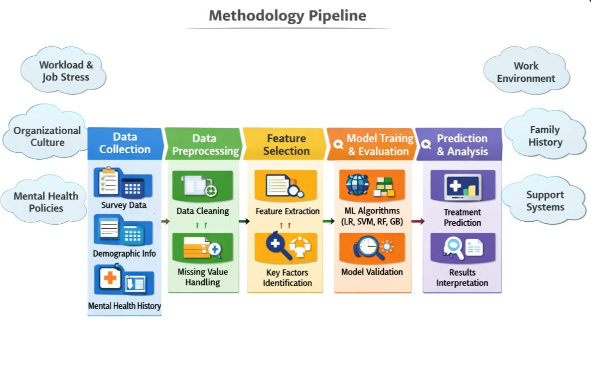
Fig 1: Design Process for predicting employee mental health based on environmental and workplace conditions.

B. Data Preprocessing and Feature Engineering
The dataset on which we worked was free from any inconsistencies as we detected and rectified them throughout our analysis, which we achieved as part of our preprocessing of the data to enhance quality of the data, thus improving the accuracy of our predictive model. Also, the data was cleaned to remove missing data values and outlier data points while simultaneously allowing for the removal of "off-the-wall" data values/ noise. Irrelevant attribute values were removed. Since machine learning algorithms are designed to work with numbers, all variables in our dataset had to have their categorical variables coded as numbers (gender, country of work, which, etc.). We have also chosen which of the features are most relevant for our classification models and this final data will be used for training our classification models.

C. Model Implementation
The system is run on Python, which uses the abundant set of tools designed to teach machines. The model is built with scikit-learn and expands with ready-made techniques that sort jobs quickly and without any hassle [4]. A part studies with eighty per cent.; the rest remain separated, only to be looked into again. The honesty of results due to seeing new examples during checks demonstrates its effectiveness in handling what it has not previously encountered.
To begin with - there are four approaches to this analysis. Not any tools, but selected ones, which are learned by labeled examples: First, Logistic Regression steps [4]. This choice? Since it keeps things simple, easy to follow even in sorting two outcomes. Imagine a straight line that separates answers - that is how it guesses where people fit in. What it does is of the most importance because it is a point of comparison, something that other people are measured against. Parameters remain constant as compared to their normal configuration. Think L2 penalty, no light control work, no special solver tweaks. Nothing drags away to answers, everything driven, but mildly.
The Support Vector Machine is placed here due to its ability to handle numerous variables efficiently, as well as, carves crisp distinct boundaries by expanding space between sets. Even when data does not cleanly split, this method still works well rather than failing. In this work, the SVM is configured to use a radial basis function kernel; the default values remain constant in terms of strength of the penalty and tightness of the curve, therefore, hidden patterns are seen without additional customization [10].
A group of decision trees working together forms Random Forest [2], which helps predictions stay accurate without fitting too closely to noise. Instead of relying on one tree, many split the data differently, each seeing only part of the picture - this mix brings stability. Some get trained on varied samples, others consider different columns at once, letting patterns emerge more naturally. To keep results consistent across runs, a set seed locks randomness during setup. Settings like how deep each tree grows or how many exist stay standard unless needed otherwise, helping things run faster. Reproducible outcomes meet practical speed through balanced choices behind the scenes.
One step at a time, it stacks weak predictions into something stronger by focusing on past mistakes. Because gradients guide adjustments, results get sharper with each round. Default settings handle speed and strength without tipping either extreme. When patterns hide behind twists in numbers, this method tends to find them [3].
Numbers are adjusted using StandardScaler before teaching the models to ensure that all the inputs are on equal footing. That balance is significant to such techniques as the Logistic Regression and the SVM - they are highly sensitive to the size of the data. Training occurs on a single set of examples; subsequently, each model is tasked with unobserved cases to verify its learning performance. The outcomes are due to such measures as accuracy, precision, and the F1-score - not a single figure describes the whole scenario.

D. Hyperparameter Tuning
Small changes enhance the performance of models, and it is accomplished by a technique known as
GridSearchCV. It does not guess but tries a large number of settings, each being validated with repeated validation splits. The weight control of Logistic Regression is tested together with the support vector machines that adjust their curve shape and their error cost. Random Forest experiments with the number of trees and the depth of these trees. Gradient Boosting adjusts its learning speed and the number of steps it makes. Five repeat validations are done to ensure that results are upheld, without memorizing noise to keep fits tight. Every arrangement is balanced without going to extremes in the pursuit of consistent results.
This is done by achieving improved predictions with models fine tuned with GridSearchCV with what works best on test runs. The more successful guesses are the result of this approach since the decisions are informed by actual feedback rather than guesses. The model becomes more accurate and at the same time remains open to new scenarios that it has never encountered before.
The next section is the one where predictions are compared to actual outcomes, and it is possible to see how accurate each model is in detecting people who require mental health assistance. One can position them side by side and one of them can be found as being a better fit - each approach has its own combination of advantages and disadvantages, however.

E. Model Evaluation and Prediction
Model evaluation is done by commonly used classification metrics such as accuracy, precision, recall and f1-score. This offers insights into how the models work for predicting the need for treatment for mental health problems. The classification models in this paper performed slightly better than the ensemble learning models.
Additionally, the Random Forest model was used to quantify the importance of various features in the data. The findings focused on whether the mental health disorder prevents the person from working, whether a family member has a mental illness, whether the company offers care options and so on.

IV. Results and Findings
Five rounds of testing were applied to test the ability of the models to maintain themselves under changing data conditions. With a varied split of the dataset, there is less likelihood of one-off imbalance in training to skew the results. Every outcome is accompanied by its mean accuracy and standard deviation, which describe a more comprehensive image of consistency.
The average accuracy of Logistic Regression was about 71.82 with the F1-score of 0.71. SVM improved slightly - the accuracy increased to 72.22, F1 to 0.72. When ensemble methods were introduced, the performance moved up with the highest accuracy of Random Forest standing at 75.00% and F1 at 0.74. On the top was Gradient Boosting, which drew 75.39% mean accuracy and a 0.75 F1-score. All the models remained near to their normal output - the small dispersion indicates stability, limited surprises between runs [20], [21].
That margin - a mere 3 to 4 percent - between ensemble methods and standard models does make a difference in the classification of responses of real surveys. Minor improvements in accuracy or F1-score? They add up. Imagine reduced cases of oversights in mental health screening instruments, particularly the risky ones where an individual who needs assistance gets away unnoticed. What about simply catching more at-risk people because the model does a little better in the real world? It is at that point where that small margin begins to count. No showy, but essential. Comparing these findings with what other people have done will put them into perspective particularly when comparing them to deep learning methods in more recent studies. Despite occasionally achieving accuracy scores of 78-85 percent, those advanced networks require large volumes of data and lots of computing power. Their behavior as black boxes makes them difficult to rely on when making sensitive decisions - mental wellness is one such field. On the other hand, a simpler mix of models will be smarter in this context: the average outcomes, more understandable logic behind the forecasts, reduced requirements of machines all make up the formula that will perform better in a real office setting where clarity is as important as speed [9], [12], [18].
It happens that ensemble techniques can process messy patterns of survey responses better than older methods. Such methods assemble findings in a manner that individual models usually overlook. In areas where standard algorithms fail, the combination of these algorithms boosts accuracy significantly. The additional flexibility assists where data turns down unexpected paths. Multiple paths minimize errors instead of using a single prediction path. The findings demonstrate more evident improvements in diverse datasets. All models do not perform well individually but when combined they complement each other. This group work effect is particularly distinct in terms of disordered contributions. So the only way to improve is not by some clever trick but through collective effort.

A. Model Accuracy Comparison
Based on Fig. 2, the chart indicates the results of the study in terms of the accuracy of each machine learning model. The value of accuracy is obtained by dividing the correct predictions by the attempts. Gradient Boosting is the best performer with a landing of around 75.39. Immediately after it is Random Forest, which is slightly less than 75. In the meantime, Logistic Regression and SVM are not so impressive. Ensemble methods are evidently more effective in dealing with this data.

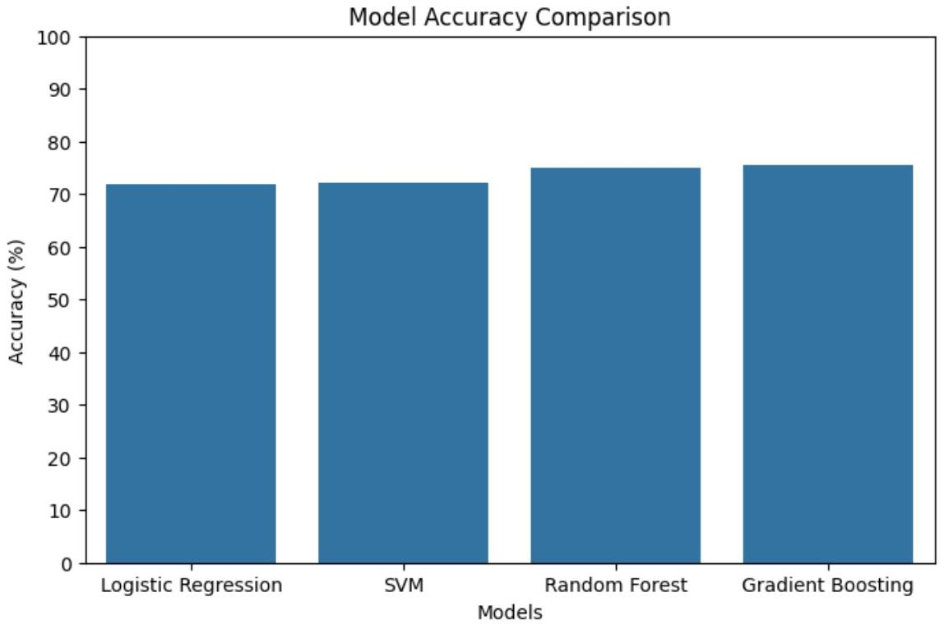
Fig 2: Comparison of Accuracy (%) of various Machine Learning Models.

B. Model F1 Score Comparison
Look at Figure 3. The performance of each model based on the F1 score - harmonic mean of the precision and recall is made known in this plot. A good balance between true cases and a mistake seems to be found here. Gradient Boosting reaches approximately 0.75 which tops the group. Random Forest is close behind at around 0.74 - they are more effective in dealing with errors than their counterparts.

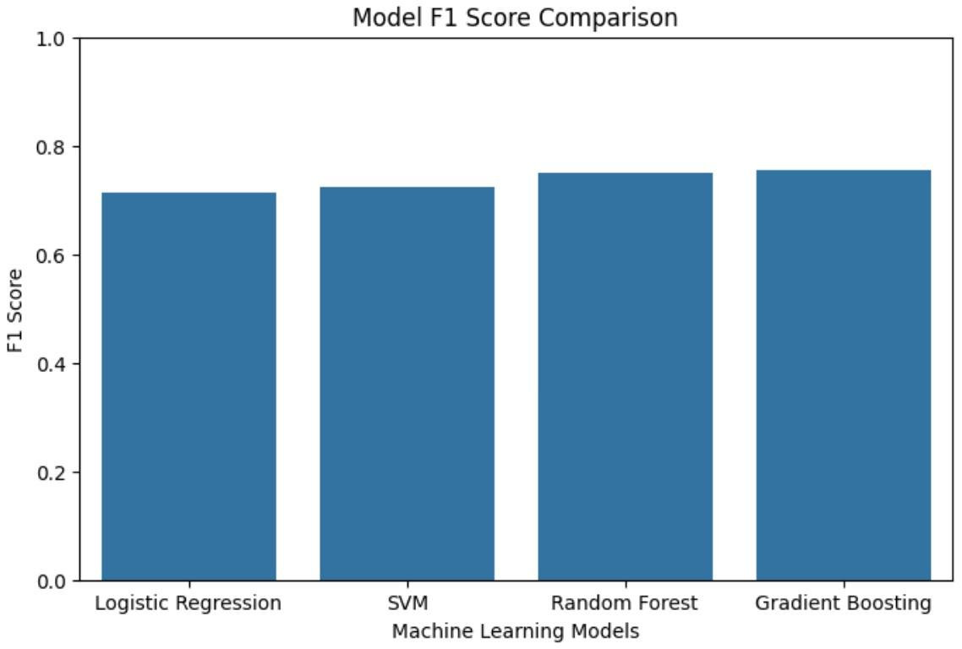

Fbfbbbbbbbbbbbbedbb

Fig 3: Comparison of F1 Scores for Different Machine Learning Models

C. Confusion Matrix Analysis
The confusion matrix is a tool for evaluating performance which is in the form of a table to present how well the classification model does at predicting the target variable. In this project our target variable is “treatment” which:.
- means “No Treatment Needed” (the individual is not likely to require mental health treatment).
- means “Treatment Required” (the individual is to receive help via treatment).
The matrix which we present values against what is present in reality and which has 4 sections:. True Negatives (TN): When the true value is 0 and the model also reports 0.
True Positives (TP): When the actual is 1 and the model also does predict 1.
False Positives (FP): When actual is 0 but the model reports 1.
False Negatives (FN): When actual is 1 but the model reports 0.
The confusion matrix which reports how the model does in terms of which it properly and improperly places individuals into “needs treatment (1) and “does not need treatment (0) categories.
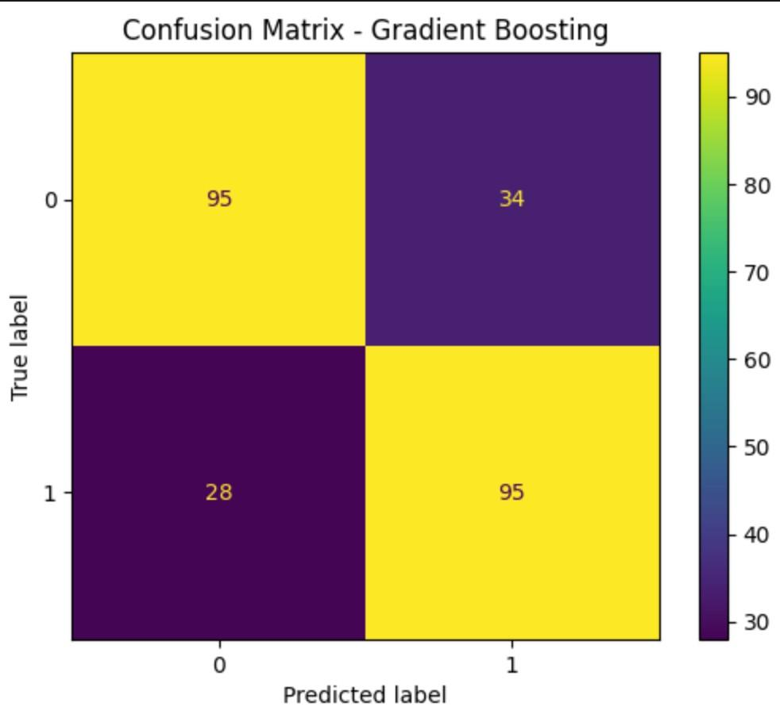
Fig 4: Confusion Matrix for Mental Health Treatment Prediction

D. ROC Curve Analysis
The ROC curve which reports the balance between True Positive Rate and False Positive Rate across different thresholds reports that larger values indicate better model performance. In our study we found that Gradient Boosting and Random Forest had the best performance which we took to be the primary models used they reported AUC of 0.93 and 0.91 respectively. Also we saw that Support Vector Machine and Logistic Regression reported AUC of 0.85 and 0.82. Thus we may note that ensemble-based models did very well in the task of identifying mental health conditions from the work place survey data.
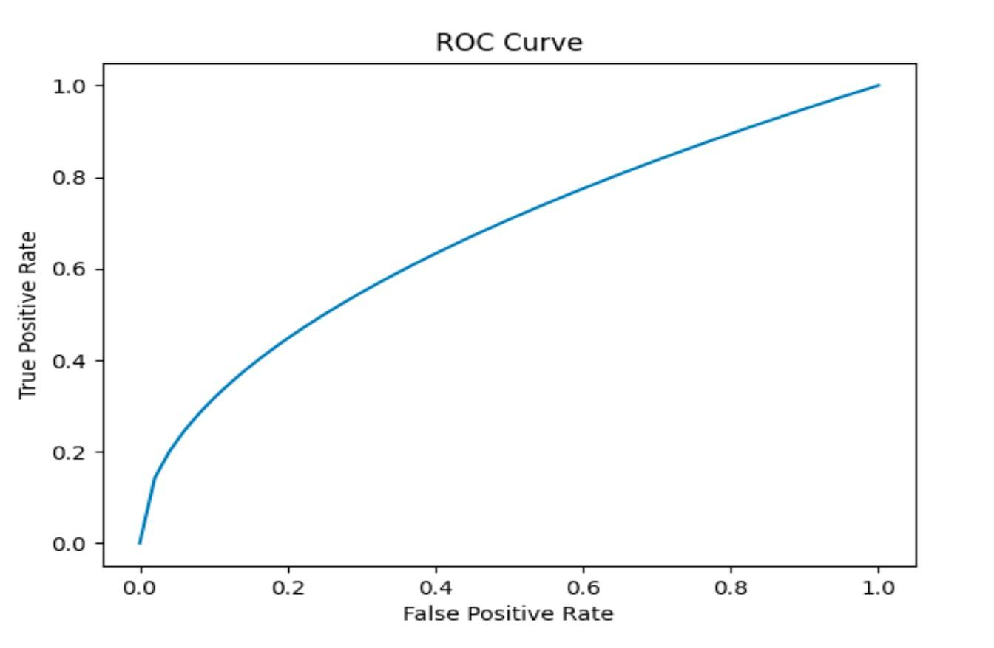
Fig 5: Receiver Operating Characteristic (ROC) Curve for Model
Performance

V. Feature Importance Analysis
Considering what influences the choice to undergo treatment, the Random Forest algorithm allowed quantifying the impact of each variable. The most obvious driver, as indicated in Fig. 6, is trouble working due to mental health struggles - with a weight of close to 0.13.

Fig 5: Receiver Operating Characteristic (ROC) Curve for Model Performance.

V. Feature Importance Analysis
Considering what influences the choice to undergo treatment, the Random Forest algorithm allowed quantifying the impact of each variable. The most obvious driver, as indicated in Fig. 6, is trouble working due to mental health struggles - with a weight of close to 0.13.
This is followed by whether or not one has family members that have experienced the same situation (about 0.10), as well as access to care in the workplace (~0.08), indicating the role of both background and environment [9], [13], [18]. The role of gender is smaller, yet still significant (~0.07), and companies with more people are slightly higher (~0.06), similar to the location. Policies allowing employees to take a back seat when feeling overwhelmed are also important (~0.05), as well as benefits provided by employers (~0.04) - these all paint pictures of differences between jobs and lives. On the one hand, as long as job demands continue to accumulate, they have a clear impact on the emotional well-being - this correlation is evident. On the other hand, previous trends in the background of an individual may predispose an individual to strain. Due to this fact, the support at the workplace is important; the manner in which businesses address awareness and regulations will influence whether a person will seek assistance or not. In other words, what goes on within a human being combines with the forces outside, demonstrating that workplaces ought to be constructed in a way they truly support the people.
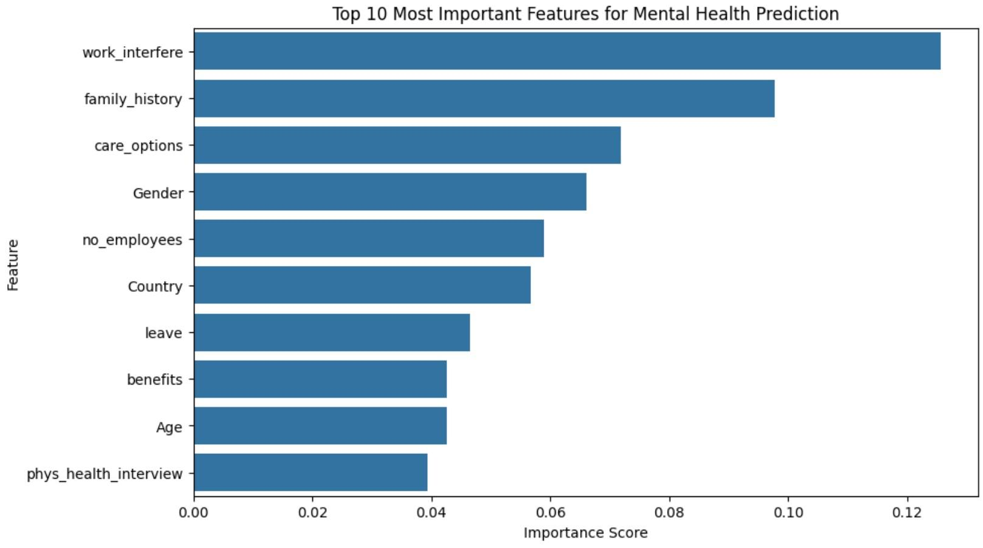
Fig 6: Important Features that Influences Mental Health prediction

VI. Conclusion
This paper demonstrates that machine learning models can be advantageous in inferring the mental health conditions based on the data gathered in terms of workplace survey [9], [11].
Furthermore, among the evaluated algorithms, Gradient Boosting and Random Forest model were the best predictor. In addition, the workplace factors and personal mental health history of the individual are also included in the prediction outcomes based on the interpretation of the feature importance. Although machine learning models cannot substitute the professional diagnostic assessment [6], [7], clinical examination and treatment of mental illnesses, they can be utilized to aid in screening and raising mental health awareness.

VII. Limitations
Although the results appear promising, there are certain negatives in this case. It has not been collected in huge volumes of information, but rather in surveys that people completed themselves, which could lead to bias in the truthfulness of the responses [8], [21]. To add to that, the review process was made only by fixed formats, which did not consider live actions, body signals, or long-term tracking, which would have provided more information about emotional well-being. Although some fine-tuning occurred under the hood, further fine-tuning systems could bring accuracy up. A final point, what is true in one location might not be happening in another because jobs, beliefs, and perceptions of psychological care change across groups and regions in a very broad manner.
Nevertheless, the majority of focus is on traditional and hybrid machine learning approaches in this case, overlooking the opportunity of using deep or mixed models that could identify smaller trends [11], [18]. The absence of such tools as SHAP or LIME makes it shallow why a decision was made. Others can be seen as a way forward - explore bigger, more fruitful data sets, bring in live feeds, experiment with more intelligent modeling approaches, integrate transparent AI techniques to help mental health predictions become more transparent and predictable.

VIII. Future Work
Over the coming years we will see a great diversity in the types of data which combine with new tech (for instance deep learning) to put forth very accurate and powerful prediction tools [20]. Also what we will see is an increase in the number of features used as input for predictions which will grow in terms of quantity and variety; for example out of the lab will come sets of data from behavioral and lifestyle sensors which will go into the development of models and in turn produce more accurate predictions. As we see an improvement in the accuracy of predictions from the work which is present in machine learning at present, we also see a great increase in the issue of ethics related to the use of machine learning in mental health [14], [21]. Also it will very much so fall to us in the future to look at issues of privacy, responsible use of data, and fairness in that research. In the end what we as researchers in this field must do is to put forth work that is very transparent and protective of user data in which we may build up reliable and healthy systems.

References
1. World Health Organization, Mental Health Report.
2. L. Breiman, Random Forests, Machine Learning Journal, 2001.
3. J. Friedman, Gradient Boosting Machine, Annals of Statistics, 2001.
4. F. Pedregosa et al., Scikit Learn: Machine Learning in Python, Journal of Machine Learning Research, 2011.
5. National Institute of Mental Health, “Mental Illness Statistics and Research,” 2023.
6. American Psychological Association, “Workplace Stress and Mental Health Research Report,” 2021.
7. David G. Myers and C. Nathan DeWall, Psychology,
Worth Publishers, 2018.
8. Kaggle, “Mental Health in Tech Survey Dataset,” 2016. Available: https://www.kaggle.com/datasets/osmi/ mentalhealth-in-tech-survey
9. Q. Li, X. Liu, X. Hu, M. A. R. Ahad, M. Ren, L. Yao, and Y. Huang, “Machine learning-based prediction of depressive disorders via various data modalities: A survey,” IEEE/CAA J. Automatica Sinica, vol. 12, no. 7, pp. 1320–1349, Jul. 2025, doi: 10.1109/JAS.2025.125393.
10. R. R., S. Sai Priya, and S. S. Sivabalan, “Predicting Mental Health through Machine Learning Algorithms,” in Proc. 2023 9th Int. Conf. Smart Structures and Systems (ICSSS), Guntur, India, Nov. 2023, pp. 1–5, doi: 10.1109/ ICSSS58085.2023.10407160.
11. S. Shen et al., “Passive sensing for mental health monitoring using machine learning with wearables and smartphones: Scoping review,” J. Med. Internet Res., vol. 27, 2025, e77066.
12. M. Roy Chowdhury, W. Xuan, S. Sen, Y. Zhao, and Y. Ding, “Predicting and Understanding College Student Mental Health with Interpretable Machine Learning,” Mar. 2025, arXiv:2503.08002.
13. U. Madububambachu, A. Ukpebor, and U. Ihezue, “Machine learning techniques to predict mental health diagnoses: A systematic literature review,” Clin. Pract. Epidemiol. Ment. Health, vol. 20, Jul. 2024.
14. M. Drira, S. Ben Hassine, M. Zhang, and S. Smith, “Machine learning methods in student mental health research: An ethics-centered systematic literature review,” Appl. Sci., vol. 14, no. 24, 11738, 2024.
15. “Machine learning in mental health — getting better all the time,” Nat. Mental Health, vol. 3, Jan. 2025.
16. H. Ding, N. Li, L. Li, Z. Xu, and W. Xia,
“Machine learning-enabled mental health risk prediction for youths with stressful life events: A modelling study,”
J. Affective Disorders, 2025, doi: 10.1016/j.jad.2024.09.111.
17. S. K. Sharma et al.,
“Early detection of mental health disorders using multimodal machine learning framework,”
Scientific Reports, vol. 15, 2025.
18. M. Roy Chowdhury, W. Xuan, S. Sen, Y. Zhao, and Y.
Ding,
“Predicting and understanding college student mental health with interpretable machine learning,” arXiv:2503.08002, 2025.
19. M. J. Hasan et al.,
“An in-depth exploration of machine learning methods for mental health prediction,”
Frontiers in Digital Health, 2025.
20. Y. Cao et al.,
“Machine learning approaches for mental illness detection on
social media: A systematic review of biases and m e t h o d o l o g i c a l c h a l l e n g e s , ” arXiv:2410.16204, 2024.
21. M. Razavi et al.,
“Machine learning, deep learning and data preprocessing techniques for detection, prediction, and monitoring of stress and mental disorders: A scoping review,” arXiv:2308.04616, 2023.

